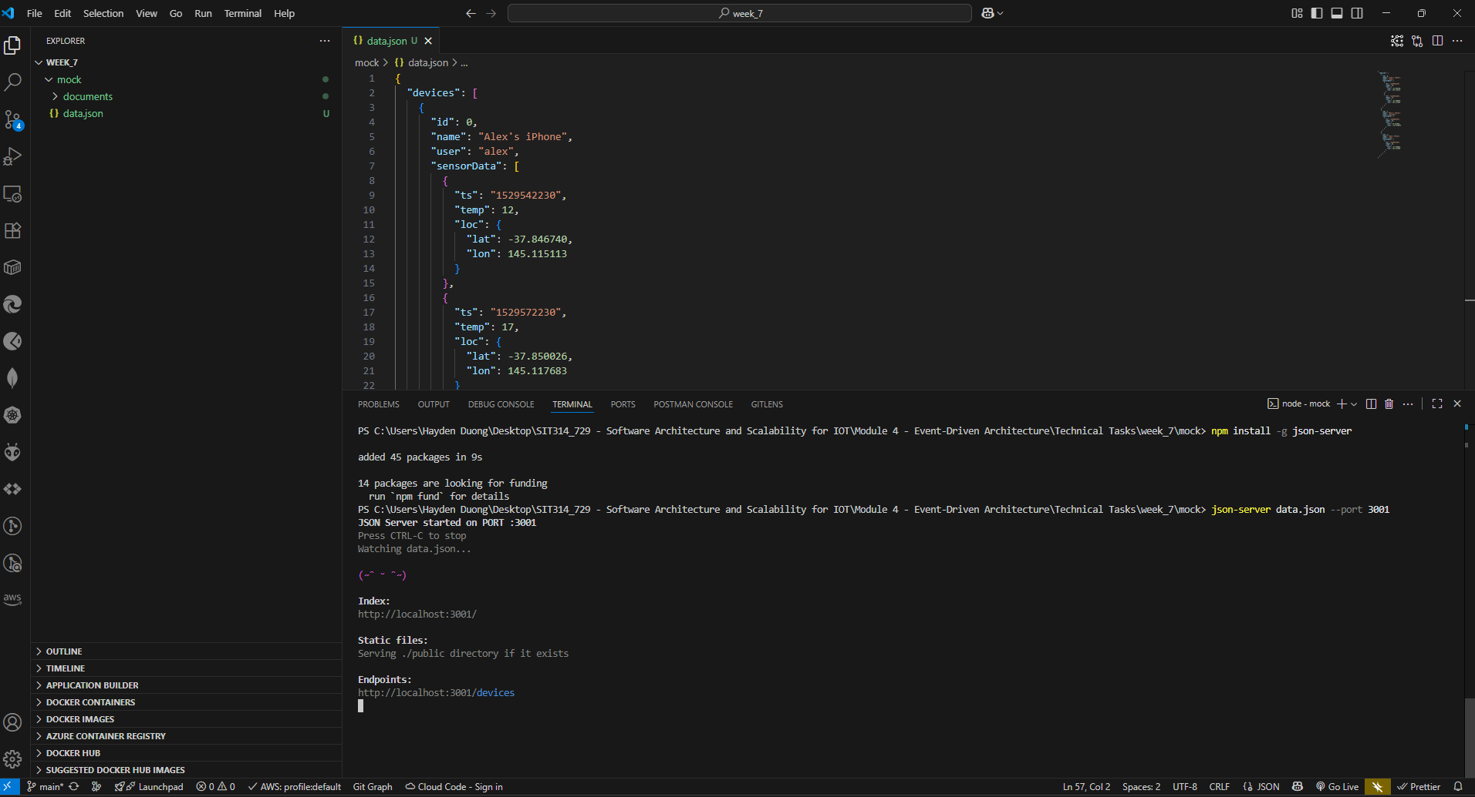
Picture 1 – Successfully run “json-server”.
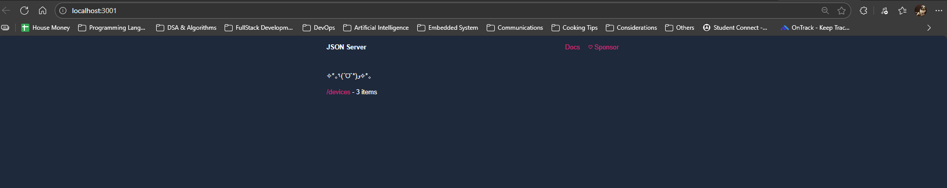
Picture 2 – Landing page of “json-server”.
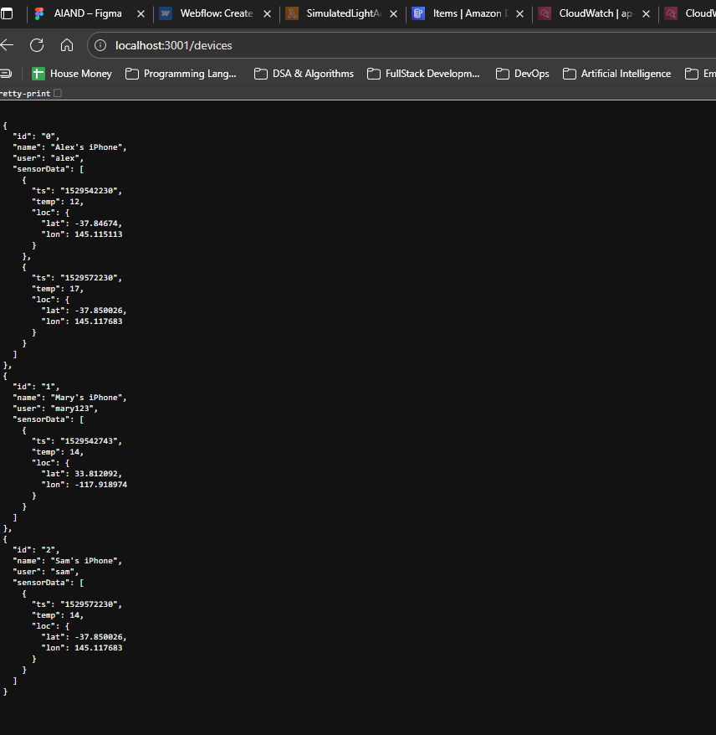
Picture 3 – Results gained from localhost:3001/devices
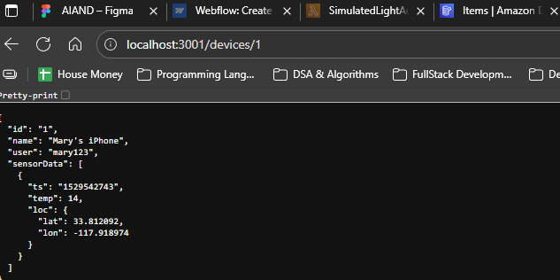
Picture 4 – Result from localhost:3001/devices/1
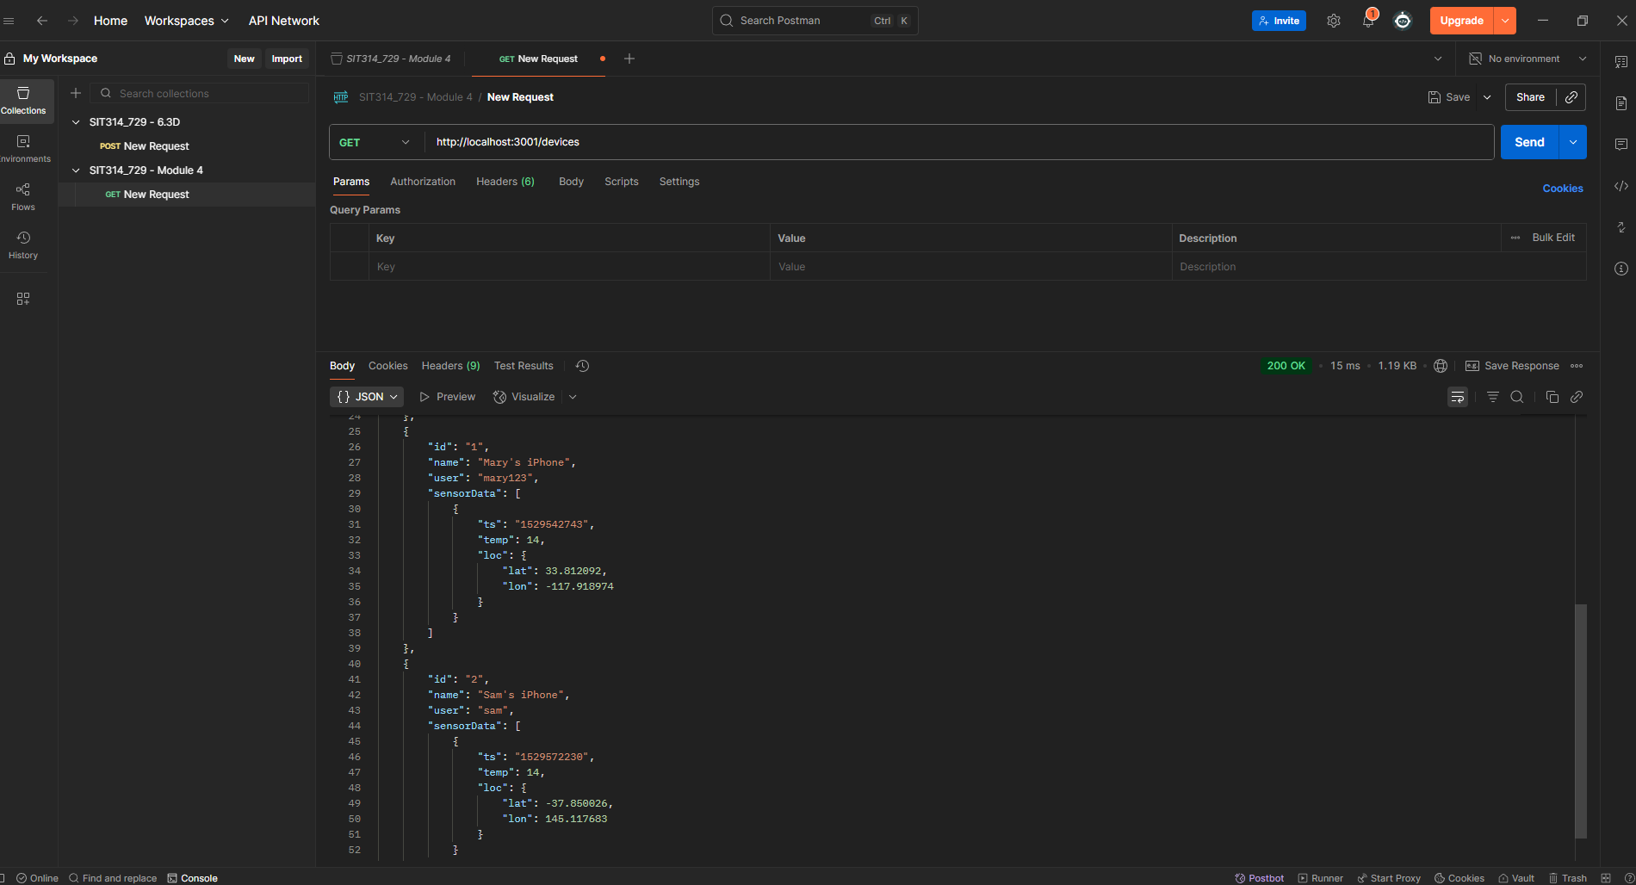
Picture 5 – Result from testing with Postman
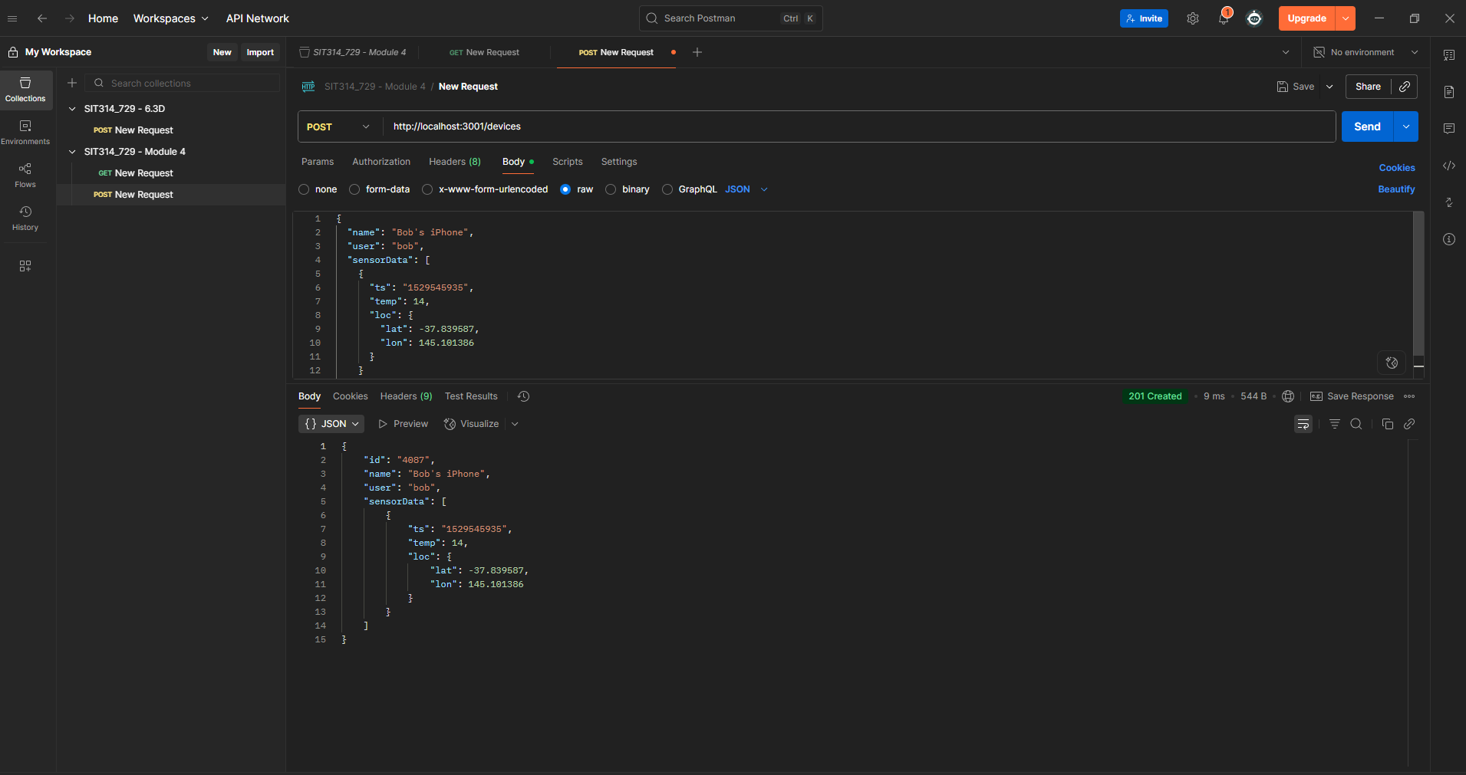
Picture 6 – Tested Post method with Postman
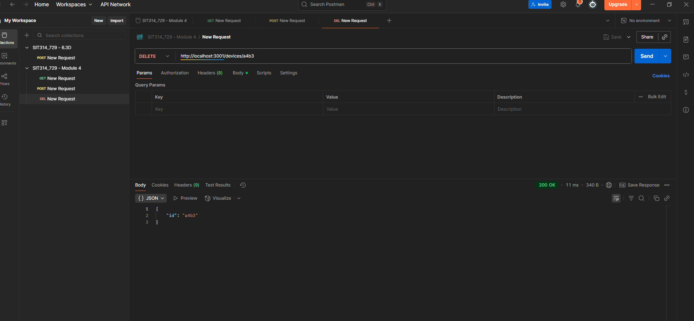
Picture 7 – Tested Delete method with Postman

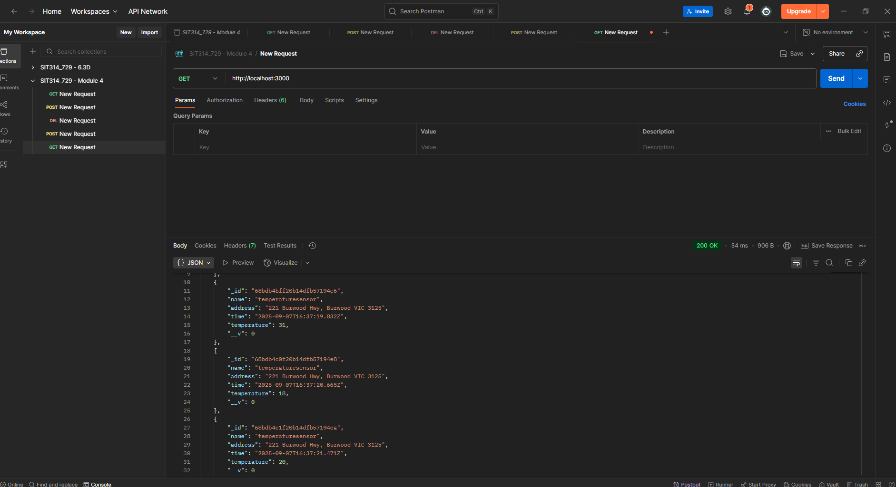
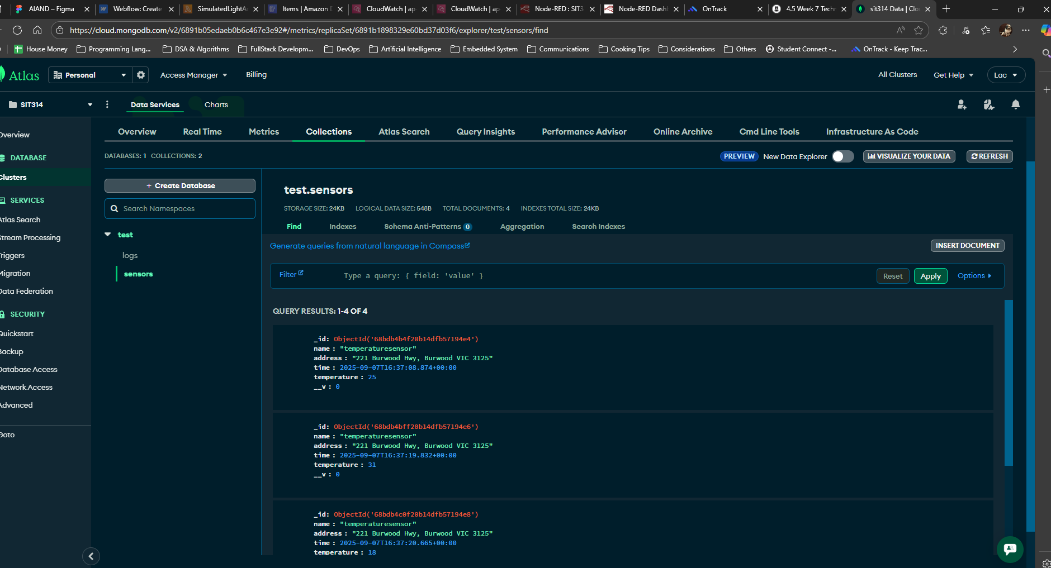
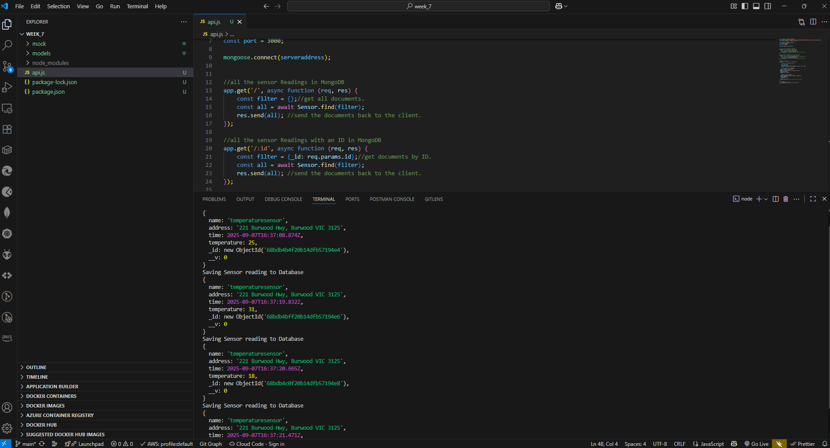
Picture 8, 9, & 10 – Results gained from Step 10 – Task 7b
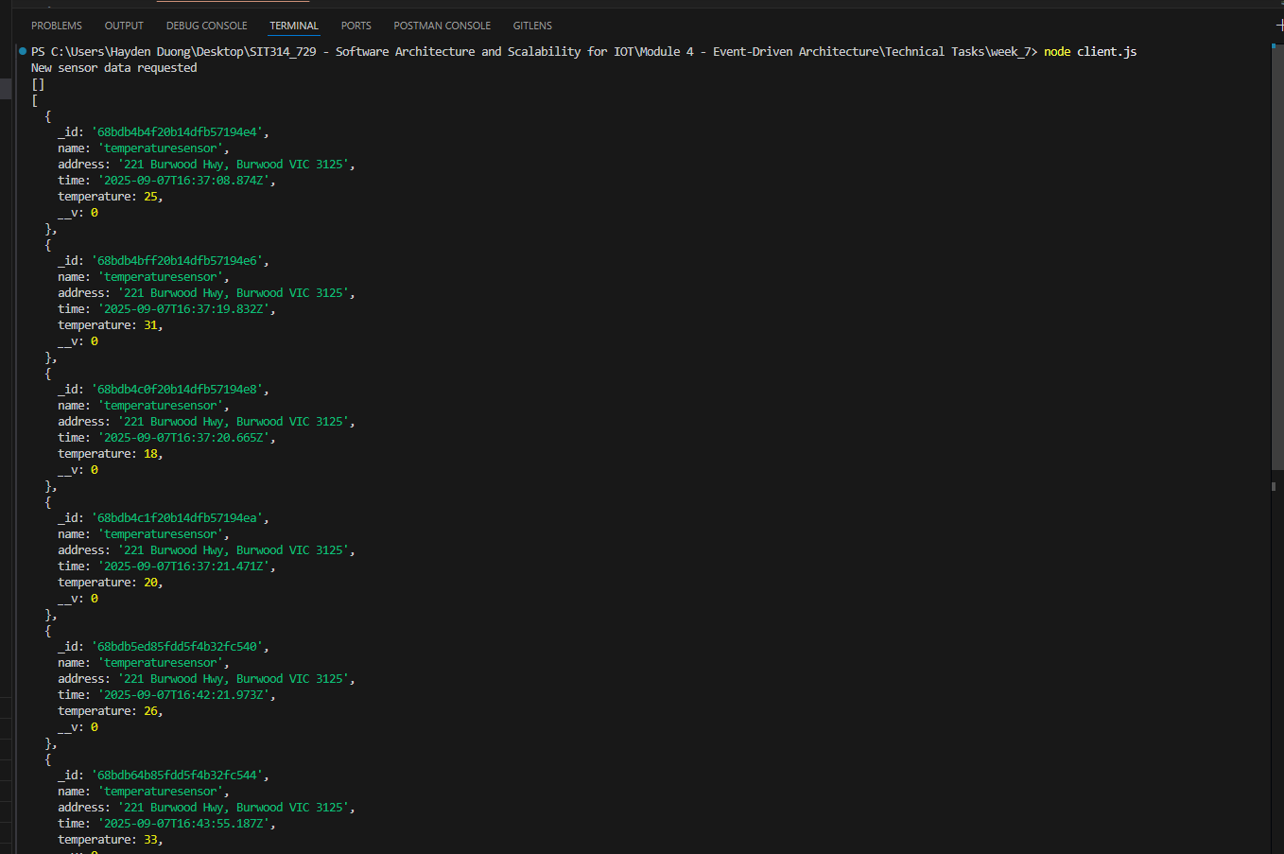
Picture 11 – Result gained from Step 1 – 5 of the final part

